Write a Prolog Program to print particular bird can fly or not. Incorporate required queries.

**AIM**

To write a Prolog program to determine whether a particular bird can fly or not.

**ALGORITHM**

1. Start the program.
2. Define facts for different birds.
3. Specify which birds **can fly** and which **cannot fly**.
4. Write rules to check and display whether a given bird can fly or not.
5. Load the program into the Prolog interpreter.
6. Query with can_bird_fly(Bird). to check for a particular bird.
7. Prolog will display whether the bird can fly or not.
8. Stop.

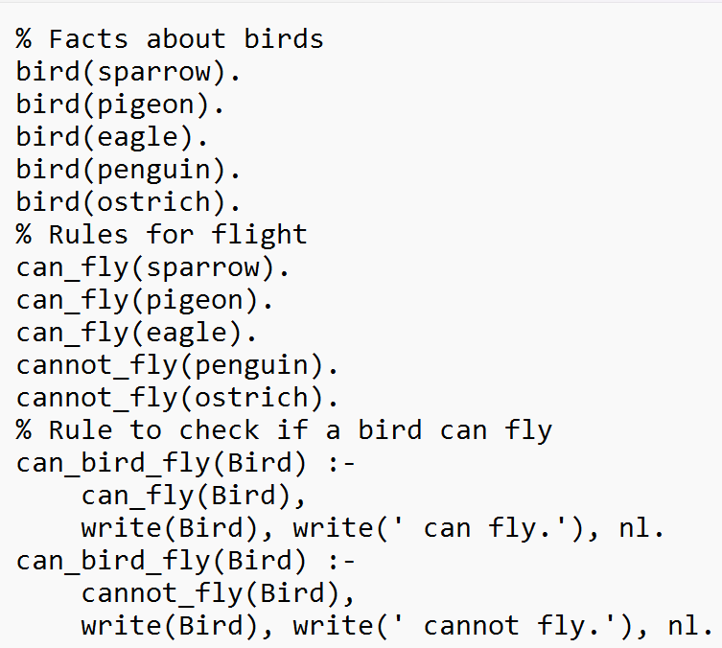

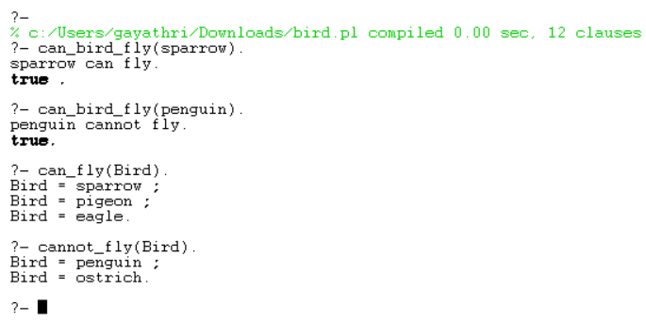

**RESULT**

The program successfully determines and displays whether a given bird can fly or not.